# Module 7_Week 8_Required Assignment_Chia

1. Identify Key Concepts of Modern Frontend Frameworks
   1. 1. Component-Based Design:   
      The design or UI is built using independent, reusable pieces of code (called components).  
        
      2. Client-Side Rendering:   
      Technique where the browser downloads the code that renders the page. Then, the web page is rendered on the client side without needing to reload the entire page from the server.  
        
      3. Declarative Programming:   
      Programming technique where the developer specifies the desired UI for a given state, rather than how to update it manually.
   2. 1. Component-Based Design Example:  
      In an e-commerce website, a ‘Product Card’ component can be reused on multiple pages like on homepage and category page.  
        
      2. Client-Side Rendering Example:  
      Social media feed app loads new post dynamically when user scrolls without refreshing the entire page.  
        
      3. Declarative Programming Example:  
      A todo app automatically re-renders the list when the state changes (eg. when a new task is added), without manually manipulating the DOM.
2. Component Creation and Reusability
   1. Student.jsx – Student Card component for brief info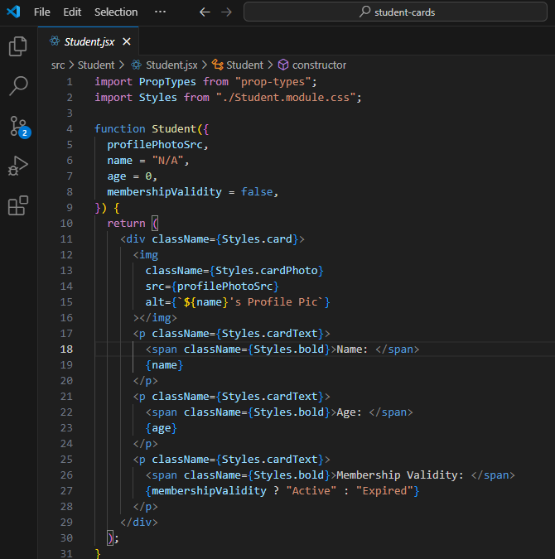  
        
      Button.jsx – Button component for more info  
      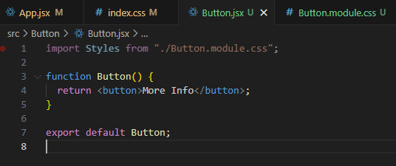
   2. App.jsx  
      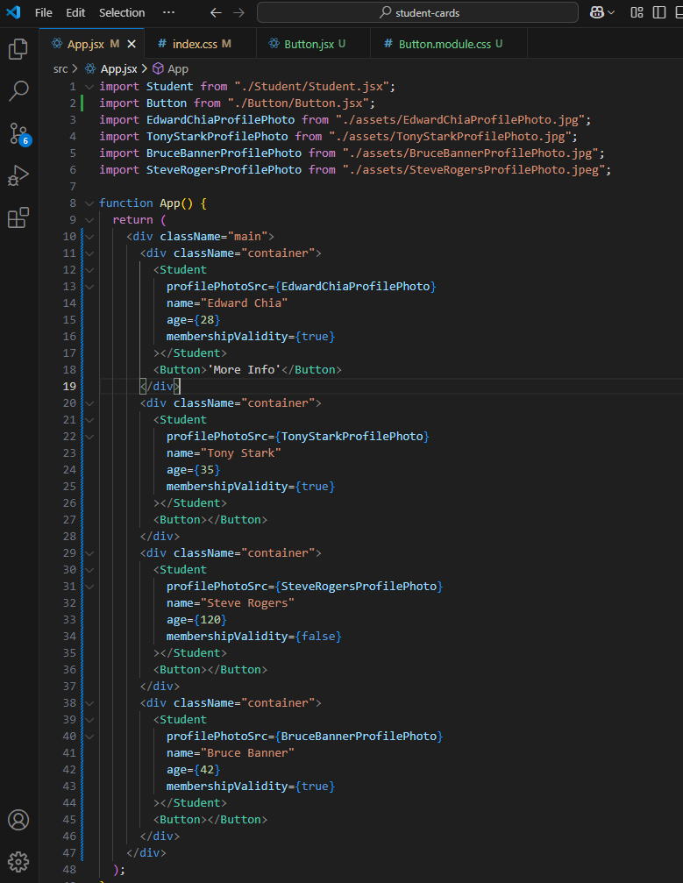  
        
        
        
        
        
        
        
      Rendered page 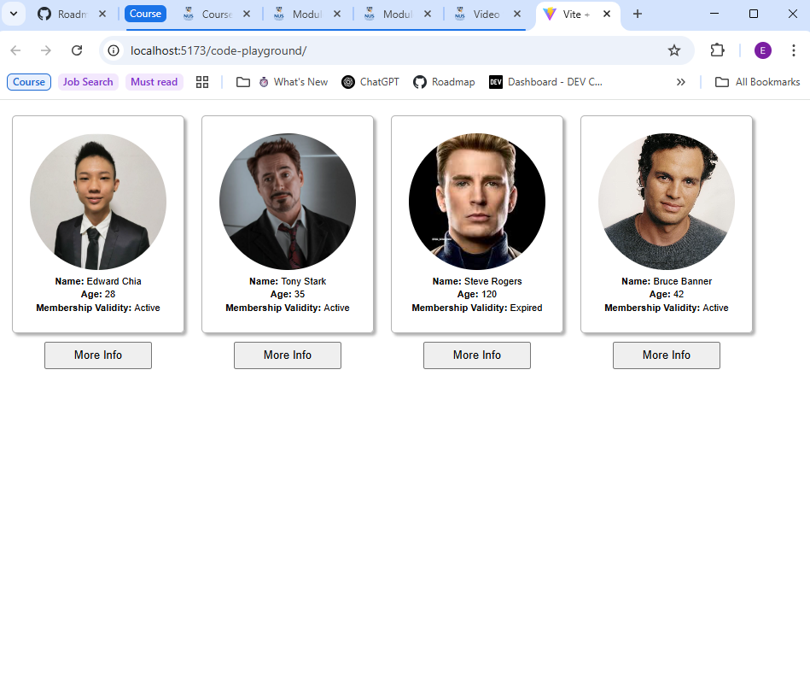
3. CSR & SSR
   1. CSR (Client-Side Rendering): Rendering happens entirely in the browser after downloading the JS code.  
        
      SSR (Server-Side Rendering): Server renders the HTML for each request and sends it to the client.
   2. Difference between CSR and SSR:  
      - CSR has slower initial load, whereas SSR has faster initial load  
      - SEO of CSR is not great by default, whereas SEO of SSR is better by default because search engines get the full page right away  
      - CSR has smooth user interaction after everything loads, whereas SSR needs to load JavaScript to be fully interactive  
        
      Advantage of CSR:   
      Great for apps where users click around a lot or need quick updates, like a dashboard, or social media.  
        
      Advantage of SSR:  
      Great for websites that want to show content quickly, like blogs or news.
4. Single Page Application (SPA) Structure
   1. SPA is a website that doesn’t reload the whole page every time you click something. It just updates the part that need to change.
   2. Advantages of SPA:  
      - Faster clicks & page loads: Since it only updates what’s needed, it feels quicker when moving around the site. No need to wait for whole page to reload.  
      - Smooth experience: User stays on one page, and everything updates in place. Has a more modern feel.